EpiData: Free software for public health data management and analysis - .

P. Arias Jens M. Lauritsen.

“What proportion of children in our schools are smokers?”, “Which types of fireworks were the cause of injuries during new year?”, “What types of food were eaten by the 75 guests at the restaurant?” or “How can we visualise the hospital wards compliance with hygiene standards over time?” – These and similar public health oriented questions arise in local settings and organisations. The typical mode of working is in accordance with general quality circle principles: Do we have a problem, who is affected, which appropriate counter measures will remedy the situation and what is the effect and efficiency of this. To work along these lines knowledge of content matter is required, but also software tools and skills in using them. Staff resources include software skills, time for acquiring skills and management of tools. Epi Info version 6 software was a main tool in this respect developed and released by WHO Geneva and CDC in USA from the mid 1980’ies to mid 1990’ies.

Stability of tools and skills in using them is a major issue, since new or changing tools requires time off from immediate tasks. Over time computers have extended speed, memory and data capacity and the core (operating system) have changed accordingly. A computer can only work if the so-called operating system allows the software to co-exist. With new versions of operating systems it is becoming increasingly difficult if not impossible to use software that worked well earlier. There are two approaches in development of software and operating systems currently. The Open-Source Linux oriented road of mutual exchange of principles and open standards and the Microsoft way (MS), which implies dependency, controlled and hidden principles. A reflection of this on the political scene are debates on software patents and very large financial penalties to Microsoft from the European Union based on lack of release of documentation for core functionality.

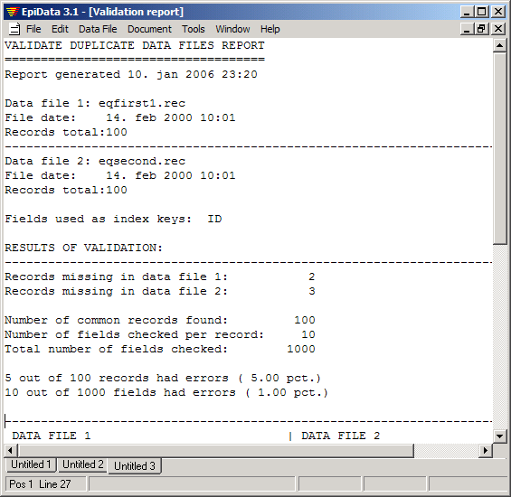
In statistical software such as Stata, SAS or SPSS labelling of data, variables and categorical values has been known for long – labelling is now called “metadata” and comprises the information needed to understand and document the data.

If open standards are followed, the metadata can be converted with the data and misunderstandings prevented, e.g. improper conclusions due to misinterpretation of groups (e.g. which code was used for males and females).

When CDC created Epi Info 2000 as the successor of Epi Info version 6, exclusive reliance on the Microsoft principles was applied. In technical terms this meant changing form a simple file form (so called qes-chk-rec principle with no database drivers) to a proprietary Microsoft form (Access database and visual basic dll’ files). Metadata principles were not included in Epi Info 2000. In short these two aspects form the essence of the motivation for EpiData software: Demands for open documented standards to secure data over time and persistence of principles. To secure that the tools well known by public health professionals can continue to be used. EpiData is released for public use for free by the EpiData Association (http://www.EpiData.dk).

The EpiData Entry Software has been translated to more than 10 languages and increasing downloads are seen over the years usually from around 100 countries every month. Training courses have been established independent of the EpiData Association. There is extensive documentation for functions and principles available for free either as part of the installation or on the main EpiData internet site (available in English and Spanish). An e-mail based user discussion group is running. The usage is also documented by a number of research publications or practice surveys from regional offices or NGO’s which have used EpiData Software.

Modules

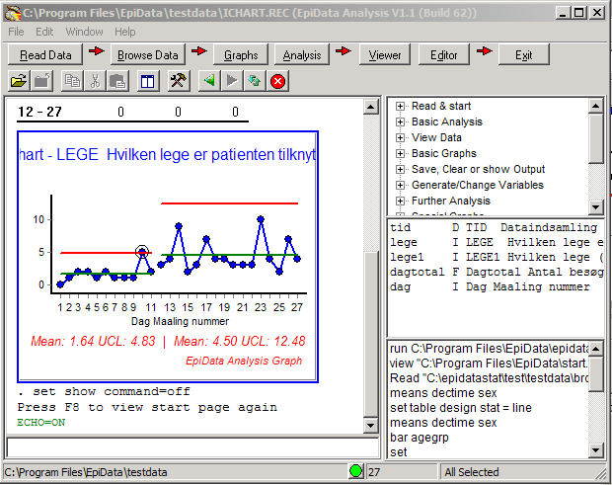
A) EpiData Entry was released February 2001. The current version 3.1 is a windows 95/98/NT based program for defining data structures,  entering data and applying validating principles, editing and correcting data already entered, asserting that the data are consistent across variables, printing or listing data for documentation of error-checking and error-tracking, comparing data entered twice and exporting data and metadata for further use in statistical software programs (Stata, SPSS and SAS). EpiData manages data stored in individual files saved in Windows’ folders. See table 1.

B) EpiData Analysis was released in September 2005. The focus of the analysis programme is extended functions and facilities for data management, aggregation of data, tabulation, graphing and descriptive analysis of data as well as quality assurance analysis (Statistical Process Control). The mode of usage can either be via menu, often preferred by beginners, or script/command line preferred by the experienced user. See table 2.

Summary:
EpiData Software is a useful tool for field work in epidemiology. Implemented principles follow open standards. It includes the most important tools any researcher or public health professional needs to maintain a high quality database during data entry and the data documentation process as well as capabilities for basic analysis in field epidemiology allowing a rapid assessment of the situation during an outbreak investigation. Simple information systems can be defined because of capacity to create a menu system, integrate a data entry tool and create semi-automatic report, including graphs with high quality output in HTML format. The demands to the computer are limited and therefore EpiData Software is also well suited for countries where IT resources are limited. The first five years has substantiated the relevance of securing the basic principles developed previously and a sustainability plan with elements as shown in table 3 has been developed for the coming five years.

Table 1. Strengths and Weaknesses of EpiData Entry
Strength
Focus on data documentation: Labels, notes, etc.
Quality Control: Double Entry, internal consistence control, legal values, ranges, conditional jumps, etc.
Data Security and Confidentiality: Automatic Backup, data encryptation (DES standard), file encryptation
Data Relationship: Hierarchical
Compatibility: Open standard, Export with labels to a Stata, SPSS and SAS. Export raw data to CSV and DBF. 100% compatible with Epi Info 6.
No interfere with the setup of the PC: does not install or include any DLL files or system files - options are saved in an INI file.
Environment: IBM compatible, Mac y UNIX
File size: Data file very light (easy to transmit)
Limitations
Single user: Only one user can access to the data file at the same time. However the software can be used by more than one user simultaneously.
Screen Design: Line oriented, only one font and colour can be set for each file.
Variables types: No multi text files are supported (memo)
Edit control: No audit trail function implemented (yet)
File size: There is a limit in the size of the QES/CHK files that the editor can handle.

Table 2. Strengths and Weaknesses of EpiData Analysis
Strength
Simplicity: Easy to use both through the keyboard or the mouse (menus).
Usefulness: It includes the basic command a field epidemiologist could need during an outbreak investigation.
Automation: It is easy to create a program to perform routine tasks
Compatibility with standard: Reads DBF, CVS and REC files. Creates standardised (W3C) HTML output
File size: Data file size very small (easy to transmit) (e.g. 10-20kb)
Limitations
Aggregated data: Weighted (summarised data) cannot be analysed.
Graphs: Is not easy to create an EpiCurve.

Table 3: Main elements of the coming five years
Independence: Maintain the independence of software manufacturers.
Rewriting: Convert all source code to Open Source cross platform.
Entry module development: Attaining GCP (Good Clinical Practice) compliance. Extending visual interface for database definition. development. Operating system independence Linux, Mac, Windows.
Analysis module development: Survival analysis (Kaplan Meier and Log Rank testing), Analysis of aggregated data, EpiCurve, extending graphs, extending menuing and reporting.
Distance based learning: Programmes should be established.
Organisational setting: Major NGO’s or organisations should take on responsibility for maintenance.
Funding: Stable funding should be secured.

